OBJECTIVE OF GRADUATION 2LABS
To enable our resources to demonstrate their capability in Data Analytics.

WHAT DO WE PROVIDE?
- Sample use case
- Data repository links
- Recommended Tools & Techniques
- Techniques of Data Visualization
- Learning platform
- Required Software / Tools / Workspace
- Mentors

WHAT ARE THE OUTCOMES OF GRADUATION LABS?
- Agilisium’s Graduation Labs grooms our resources into data professionals.
- Resources have a good exposure to end-to-end Data Analytics project (Defining the problem statement, data engineering, data visualization and presenting the insights in a story format supported with relevant data visualization)

HOW PEOPLE CAN BE PART OF GRADUATION LABS?
All the resources who have successfully completed learning labs can be the part of Graduation labs.

WHAT HAPPENS IN GRADUATION LABS?
- Once skill labs confirm their participation an official notification with relevant details is sent to the participants.
- Orientation meeting will be conducted and recorded.
- The candidates must choose a problem statement or use case.
- Then, the candidate must choose a data set (Mandatorily Dataset size should be of 1 million records or file size 3 GB to 5 GB) and the data set can either be taken from our data repository or any open-source data available. (Please refer to the picture below for the process flow)
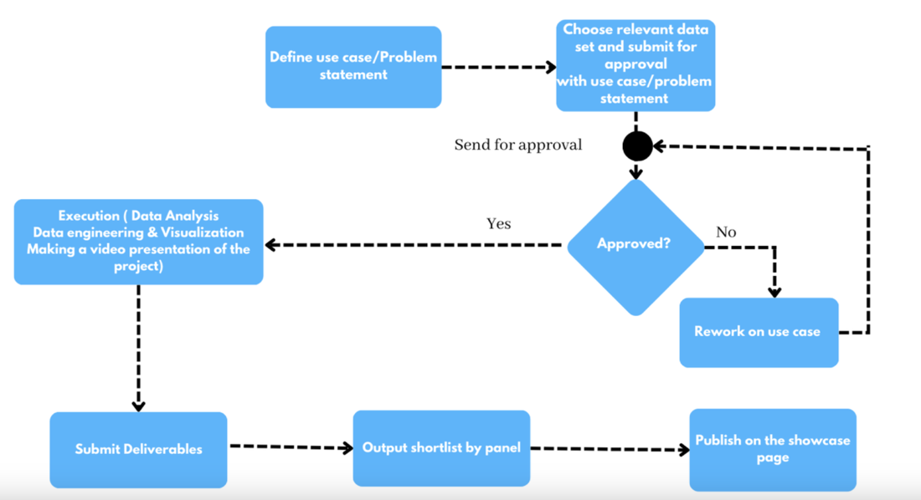
(PROCESS)

Sample data repository links (for data sources): -
  - https://github.com/awesomedata/awesome-public-datasets#healthcare. (This one link has data sets for 36 domains, for each domain it has many numbers of data set sources)
  - https://datahub.io/collections. (This link also has got multiple sources of data set for various domains)
  - https://www.kaggle.com/datasets?search=Pharma
  - https://www.kaggle.com/datasets?search=Health
  - https://data.world/datasets/public-health
  - https://www.reddit.com/r/datasets/
  - https://healthdata.gov/
  - https://registry.opendata.aws/
  - https://datasetsearch.research.google.com/
  - https://apps.who.int/gho/data/node.home
  - https://www.cdc.gov/
  - https://www.fda.gov/
  - https://data.worldbank.org/
  - https://data.unicef.org/
  - https://data.europa.eu/en
  - https://www.data.gov.uk/
- With the selected data and use case, submit it to the panel for approval through approval app.

Sample use cases: -
  - Case 1: A Procurement Director at a HealthCare Provider has asked you to design a dashboard about medical supplies pricing. The director is interested to learn how the pricing of various product groups are affected and overall trend of pricing. The HealthCare provider is launching a new line of service which requires vendors in this dataset to supply equipment's. This dashboard will be used by the director to drive decisions on vendor selection with optimal cost and shipment delays.

  - Case 2: The department of education within the state having large volume of student's data which includes their performance, demographics, and other academic information, the government of Tripura would be able to monitor and predict state/district-wise figures, plan and allocate budget with the help of data analytics.

  - Case 3: India’s budget allocation for various social schemes like NREGA, MUDRA schemes, Ayushman Bharat and various others are not properly designed. Linking of the AADHAR to various services like finance, healthcare etc. is expected to create a gigantic pool of data which will need to convert the raw data into meaningful information and facilitate analysis. These insights can help design social schemes and budget allocation more efficient.

  - Case 4: Tax evasion and money laundering is a growing menace in our society. Demonetization in India has brought about an attitudinal shift in the minds of the Indian people with more individuals now migrating towards digital payment mediums and this increasing digitization of transactions is a positively correlating factor for the Data Analytics demand in the country. Come up with insights that can help fight corruption and money laundering through Data Analytics.

  - Case 5: Cybercrimes and cyber security are threatening India’s most secured servers and Government websites. According to Cisco, India faces the highest number of cyber security threats in the Asia-Pacific region with over 500,000 alerts daily, which is nearly thrice the number of alerts at global companies. Come up with data insights that can help to mitigate threats.

- Use case and Dataset will be reviewed and approved by a panel recommended by the respective practice heads. Based on the priorities and bandwidth timelines can be confirmed after discussing with respective reporting managers and practice heads.
- Send mail to practice head with Problem statement and get approval
- Once the use case is approved, candidates must work on the project using the recommended tool/ technologies.

Recommended tools and technologies: -
  - AWS:
    - Ingestion
    - Batch - S3, DMS
    - Real / near real time – Kinesis (Streams, analytics, firehose), API Gate Way
    - Processing – Lambda, Glue / EMR, EC2
    - Loading – RDS / Aurora, Redshift, DynamoDB, Snowflake
    - Reporting – Quick Sight
    - Monitoring – Cloud Watch, X-Ray
    - Secrets store – Secret manager, parameter store.
    - Orchestration – Step functions, AWS Managed Airflow
    - Event Scheduling – Event Bridge rule

  - Databricks:
    - Ingestion – Databricks loader, Custom Scripts, Five Tran (available both free & commercial), Kafka (real time)
    - Processing – Databricks Notebook (Delta, Live tables, SQL)
    - Loading – Delta tables, external tables, Redshift, Snowflake, RDBMS
    - Reporting – Data bricks SQL warehouse, Any third-party free tools
    - Monitoring – Data bricks Audit logs
    - Secret Store – Data bricks Secret Scope, can leverage AWS Secret store.
    - Orchestration – Databricks orchestrator (task), Airflow
    - Event scheduling – To be updated.

  - GCP:
    - Ingestion – Google cloud storage, DMS, Real time (pub sub / APIgee)
    - Processing – Cloud data flow, Cloud data proc.
    - Loading – Big query, Spanner, cloud SQL, Snowflake
    - Reporting – looker or any third-party services
    - Secret store – Secret Manager
    - Orchestration – Cloud composer (Airflow)
    - Event Scheduling – cloud scheduler

  - Programming:
    - Python / Scala
    - Pyspark / spark Scala
    - SQL
    - ETL
  - Open-source libraries (Optional):
    - Data quality & observability – Deeq, Pydeeq, great expectations, Soda
    - Reporting – Apache superset (awesome product, Have multiple connector), Sisense Free version.
    - Data transformations – DBT, Meltano
  - Techniques to be used in Data Visualization (must have): -
    - Different filters (e.g.: Context filter, dimension/measure filter, etc.)
    - Use of parameters
    - Actions
    - Calculated fields & Fixed LOD
    - Use of shapes in Marks
    - Time comparison (YOY or MOM or vs previous day comparison KPI)

- Skill Labs will monitor the progress and send the weekly progress report to the RMG, practice heads and the Tech and Talent management team.

Expected deliverables: -
  - Problem statement/use case document
  - Data Analysis document
  - ETL Strategy
  - Source to Target mapping document
  - Unit testing document
  - Issue log
  - Assumption log
  - Report Specification document
  - Reports, dashboards
  - Report testing document.
  - 4 Videos
  - A professional Report
- After completion of the work. Candidates must make 4 types of videos and 1 Professional report as output and other deliverables for evaluation and submit to the panel.

Sample videos: -
  - Video 1: Explainer video on Dataset, Problem Statement/ Use case.
  - Video 2: Explainer video about Project Environment, Technical architecture, Data Integration, Data Visualization implementation
  - Video 3: Story telling with data (reports, dashboards and infographics)
  - Video 4: Making video (Screen recording of identifying the dataset to Storytelling with data)

Sample infographic summary report: -
  - Sample 1: Infographic summary
  - Sample 2: Infographic summary

- Shortlisted videos will be showcased on the Agilisium's Social Media platforms.

